



TIME SERIES FORECASTING

**Anand R J**

#### Problem Statement:

###### For this particular assignment, the data of different types of wine sales in the 20th century is to be analyzed. Both of these data are from the same company but of different wines. As an analyst in the ABC Estate Wines, you are tasked to analyses and forecast Wine Sales in the 20th century.

**Data set for the Problem:** [**Sparkling.csv**](https://olympus.greatlearning.in/courses/16932/files/2715273/download?verifier=YY8HTeyW4hfTm2tSCZM3X8PndisLMuVjfrYHznKa&wrap=1) **and** [**Rose.csv**](https://olympus.greatlearning.in/courses/16932/files/2715272/download?verifier=VMLpn9TtIeyioMLj6qYthWPIFhjpdiPCRDHGZ9qm&wrap=1)

INDEX

Contents

Q1) Read the data as an appropriate Time Series data and plot the data. 3

Q2) Perform appropriate Exploratory Data Analysis to understand the data and also perform decomposition. 5

Q3) Split the data into training and test. The test data should start in 1991. 11

Q4) Build various exponential smoothing models on the training data and evaluate the model using RMSE on the test data. 12

Q5) Check for the stationary of the data on which the model is being built on using appropriate statistical tests and also mention the hypothesis for the statistical test. If the data is found to be non-stationary, take appropriate steps to make it stationary. Check the new data for stationary and comment. Note: Stationary should be checked at alpha = 0.05. 20

Q6) Build an automated version of the ARIMA/SARIMA model in which the parameters are selected using the lowest Akaike Information Criteria (AIC) on the training data and evaluate this model on the test data using RMSE. 24

Q7) Build a table with all the models built along with their corresponding parameters and the respective RMSE values on the test data. 28

Q8) Based on the model-building exercise, build the most optimum model(s) on the complete data and predict 12 months into the future with appropriate confidence intervals/bands. 29

Q9) Comment on the model thus built and report your findings and suggest the measures that the company should be taking for future sales. 32

# Q1) Read the data as an appropriate Time Series data and plot the data.

* Monthly sales of two type of wines, such as Sparkling and Rose are given, for a period from January 1980 to July 1995.

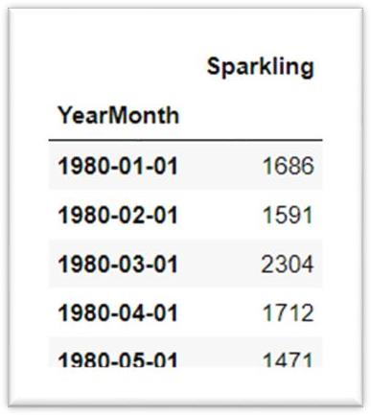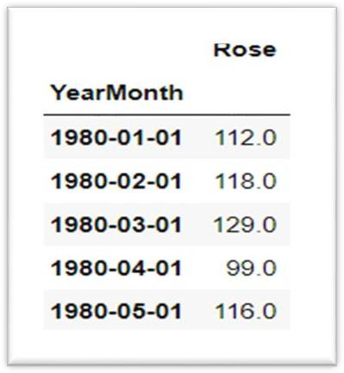

**(Data Table)**

* The given data files are read as is and a date-range has been applied on the data as index.

#### Sparkling Dataset-

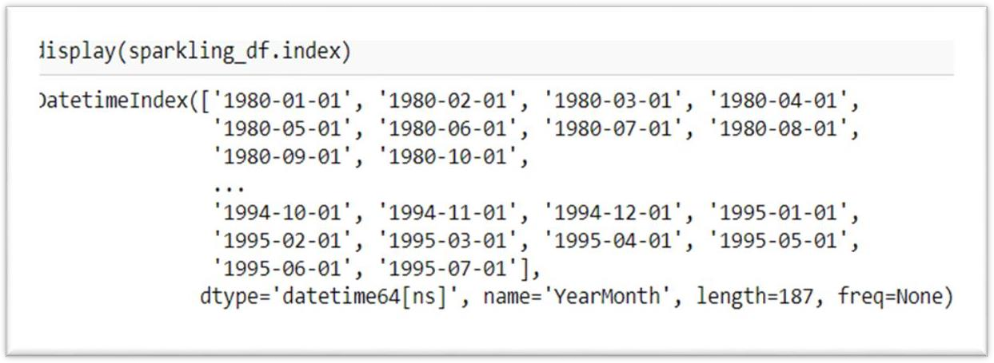

**Rose Dataset-**

**(Sparkling Date Data)**

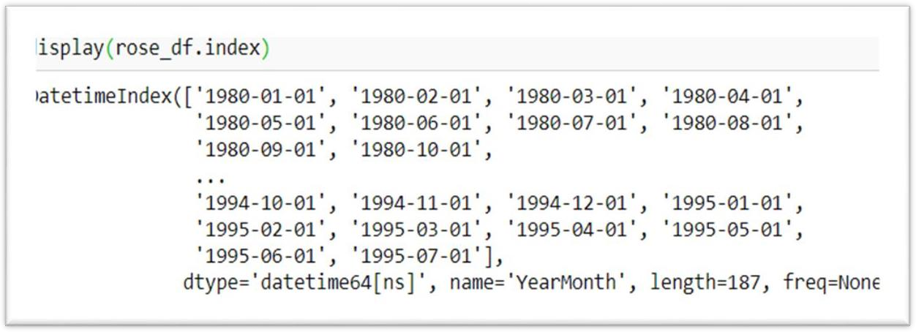

**(Rose Date Data)**

* Both the given datasets of the respective type of wines are combined to a single data frame, for the sake of comparability of the time series components and forecast.
* The Rose time-series got values missing for two months in 1994, which are imputed using interpolation (linear method)
* Rose data after interpolation for year 1994 is given below as well as the plot.
* Both the datasets show significant of the seasonality. While sale of Rose shows downward trend, Sparkling doesn’t show any consistent trend but has upward and downward slopes during the period.
* While Sparkling wine has been increasingly favored over the years by customers, the demand for Rose had been declining over the years.

#### Sales of Sparkling Wine-

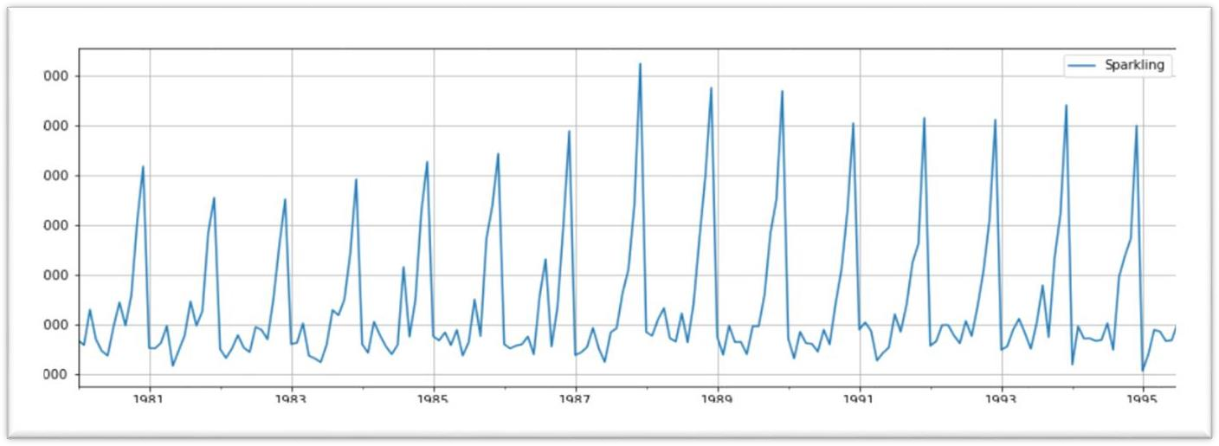

**Sales of Rose Wine-**

**(Sales of Sparkling Wine-Year)**

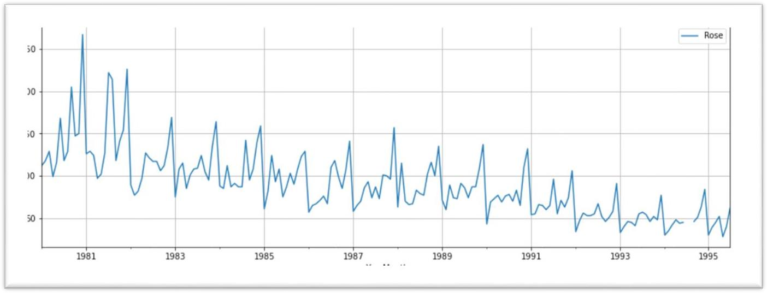

**(Sales of Rose Wine-Year)**

# Q2) Perform appropriate Exploratory Data Analysis to understand the data and also perform decomposition.

#### Sparkling-

* The descriptive summary of the data shows that on an average 2402 units of Sparkling wines were sold each month on the given period. Maximum sale reported in a month is 7242 units.

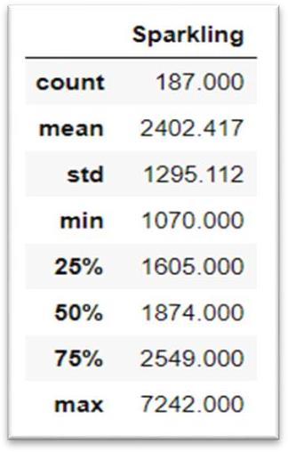

**(Sparkling Describe)**

* The yearly boxplot shows that the average sale of Sparkling has been consistent across the period, at or border line below 2000 units.

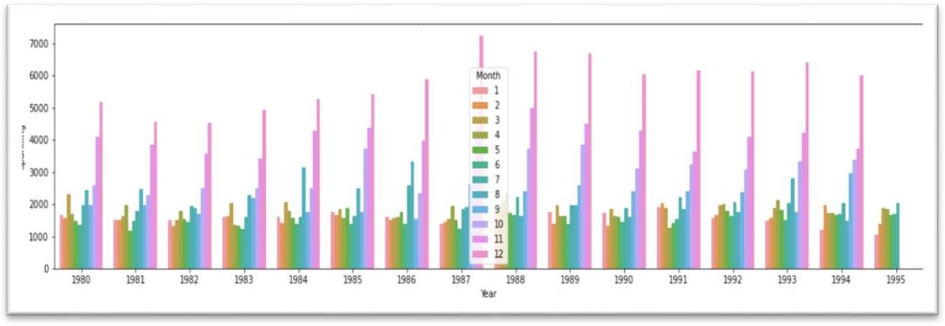

**(Yearly bar plot)**

* The outliers in the yearly boxplot most probably represent the seasonal sale during the seasonal months. Kind of like the Peak sales during the Christmas and Halloween Seasons.

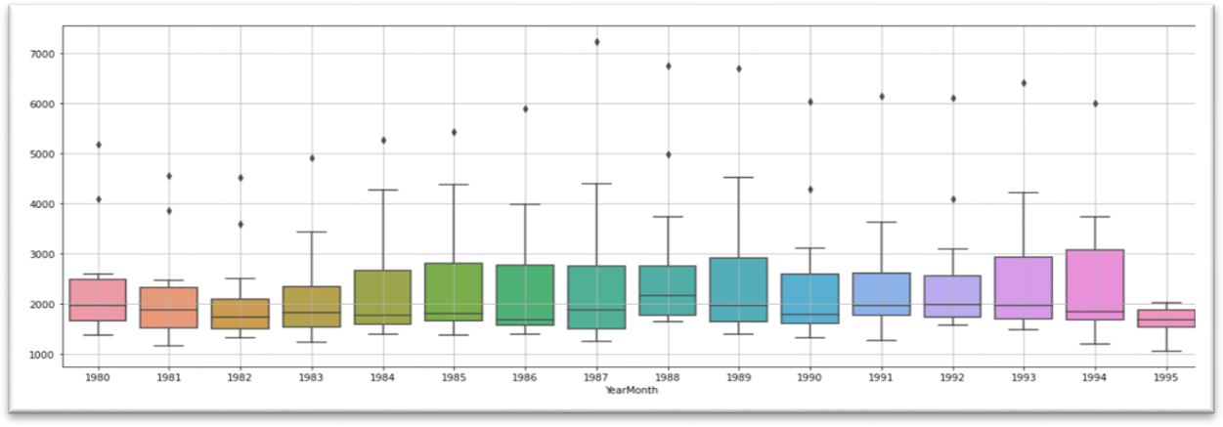

**(Yearly box plot for Sparkling)**

* The monthly boxplot shows a clear seasonality during the festive seasonal months of October, November and December, which peaks in December. As discussed in the previous point.

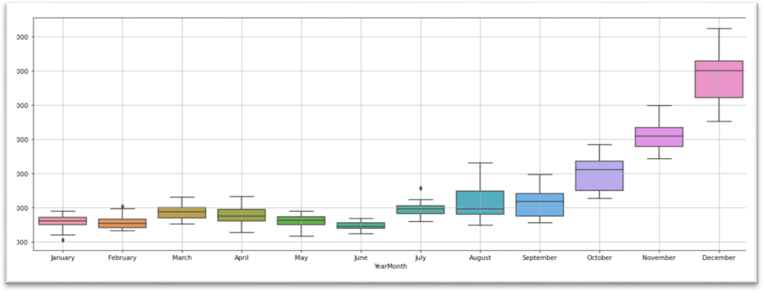

**(Monthly box plot for Sparkling)**

* The monthly plot for Sparkling shows means and variation of units sold each month over the years. Sale in seasonal months shows a higher variation than in the lean months.
* Sale in December with a mean of 6000 Units, it in general varies from 7400 to 4500 units over the years. Whereas sale in November generally varies from 3500 units to 5000 units and sale in October generally varies from 2500 to 4000 units.
* The lesser sold months from January till September show more or less consistent sale of around 2000 units.
* The plot of monthly sale over the years also shows the seasonality component of the time-series, with October November and December selling exponentially higher volumes
* The highest volume of Sparkling wines was sold in December,1987 and the least of December sale was in 1981.

**Sparkling decomposition-**

* The decomposition plots of Sparkling wine sales are given here-
* As the altitude of the seasonal peaks in the observed plot is changing according to the change in trend, the time-series is assumed to be ‘multiplicative.
* The plot of the trend component does not show a consistent trend, but more or approximately half period later shows an upward slope which gets consistent on the late half of time-series
* The additive model shows the seasonality with a variance of 3000 units and the multiplicative model shows a variance of 30.

#### Additive-

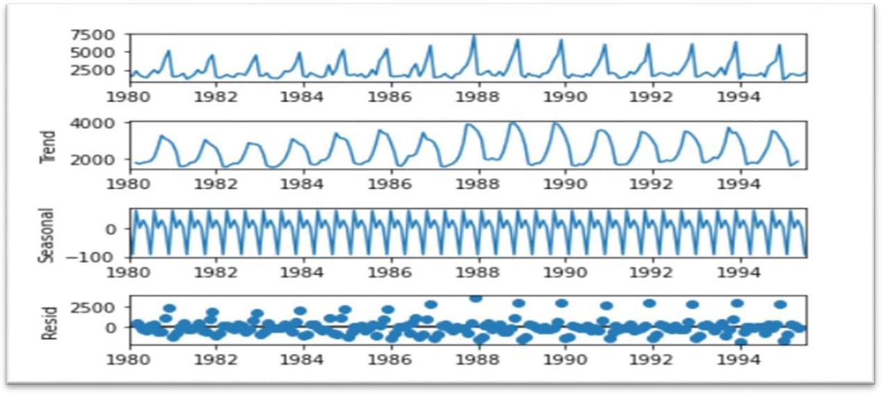

**(Additive)**

#### Multiplicative-

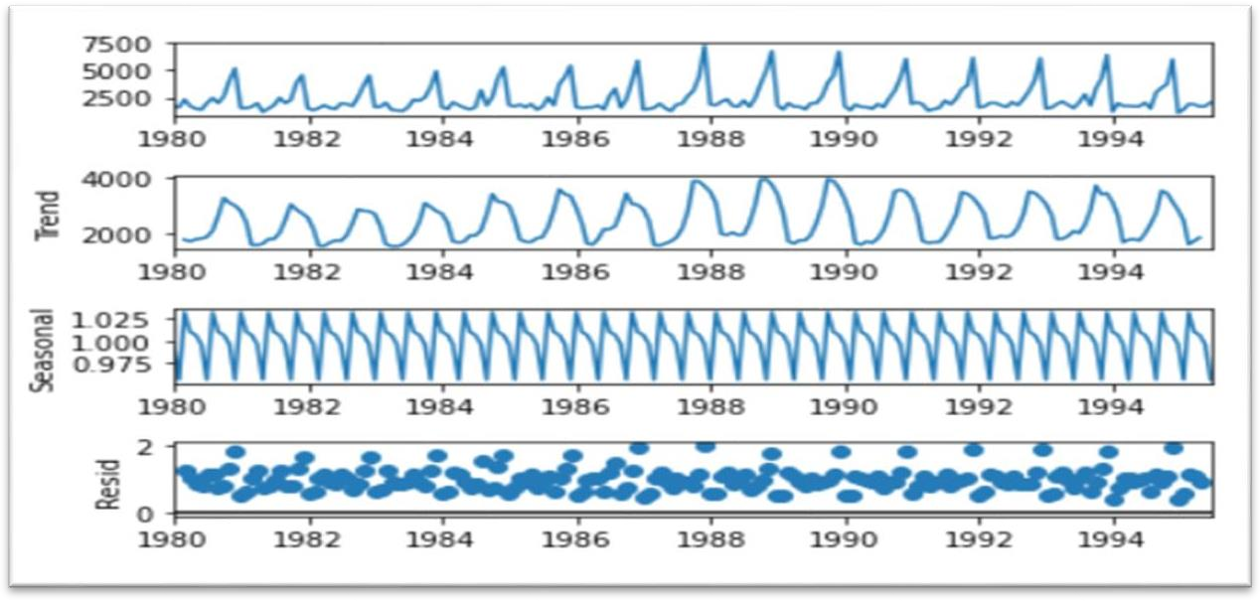

**(Multiplicative)**

* The residual shows a pattern of high variability across the period of time-series, which is consistent in both additive and multiplicative decompositions.
* The additive model shows a mean variance around 0 and the multiplicative model shows a variance around 10%.
* Sparkling dataset doesn’t show a visible trend however it shows seasonality, also if observed from additive decomposition the residual is catching some pattern. Multiplicative decomposition on the other hand seems to dictate on the series as the scale of the residual plot had decreased considerably Monthly bar plots showed that the sales are higher towards the last months than the earlier.

ROSE-

* The descriptive summary of the data shows that on an average 90 units of Rose wines were sold each month on the given period of time. Maximum sale reported in a month is 267 units and minimum of 28 units.
* The yearly boxplot, shows that the average sale of Rose wine moving according towards the downward trend in sales over the years. The outliers over upper bound in the yearly- boxplot most probably represent the seasonal sale during the seasonal months.

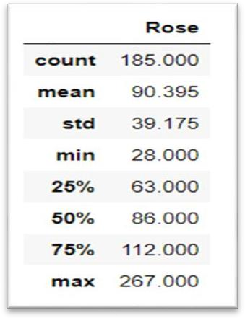

**(Rose Describe)**

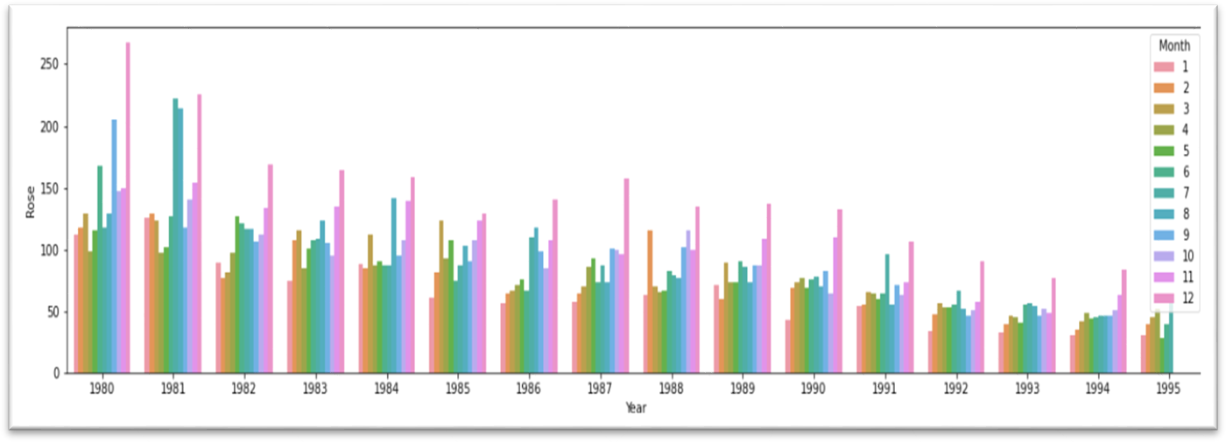

**(Yearly bar plot for Rose)**

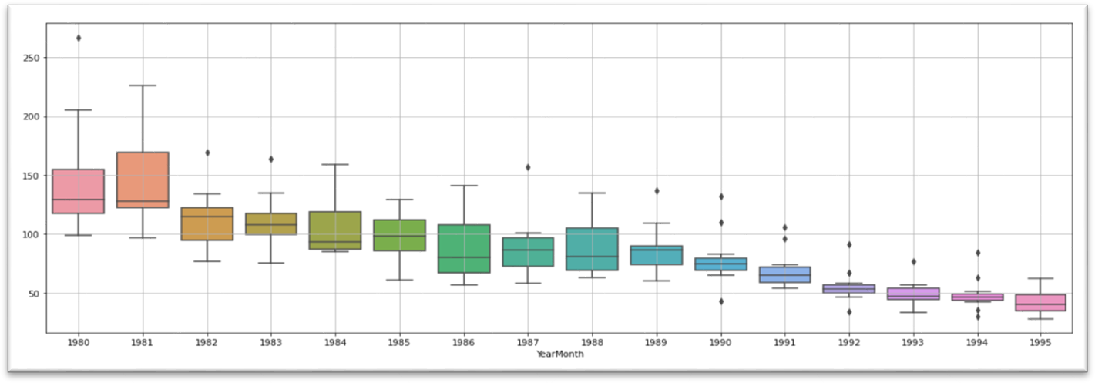

**(Yearly box plot for Rose)**

* The monthly boxplot shows a clear seasonality during the seasonal months of November and December. The sale starts to sink from the month of January, it picks up in the due course of the year.
* Average sale in December is around 140 units, November is around 110 units and October is around 90 units.

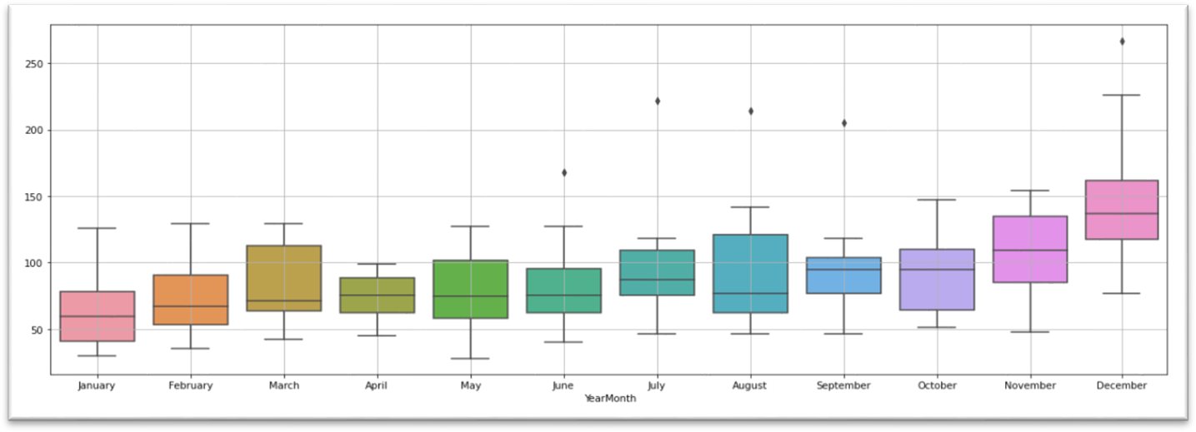

**(Monthly box plot for Rose)**

* The monthly plot for Rose shows means and variation of units sold each month over the years. Sale in months such as July, August, September, and December show a higher variation than the rest.
* The Sale in December with a mean of 100 Unit and No of sold units varies from 75 to 270 units over the years.
* The plot of monthly sale over the years also shows the seasonality component of the time-series, with November and December selling exponentially higher volumes than other months.
* The highest volume of Rose wines was sold in December 1980 and the least of December sale was in 1993.

Rose decomposition-

* The observed plot of the decomposition diagrams shows visible annual seasonality and a downward trend. The early period of the plot shows higher variation than in the later periods.
* The trend diagram shows a downward trend overall. Exponential dips can be seen between 1981 and 1983 and later from 1991 to 1993.
* Seasonal components are quite visible and consistent in both the observed and seasonal charts of the diagrams. The additive chart shows variance in seasonality from -20 to 50 units and the multiplicative model shows variance of 16%.

#### Additive-

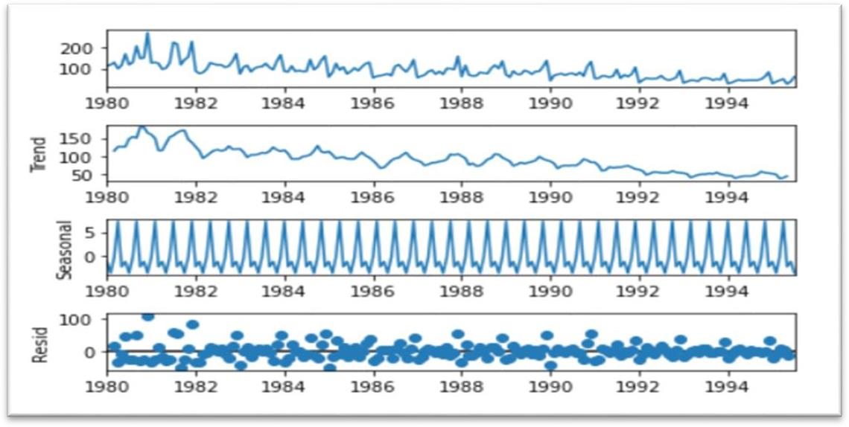

**Multiplicative-**

**(Additive for Rose)**

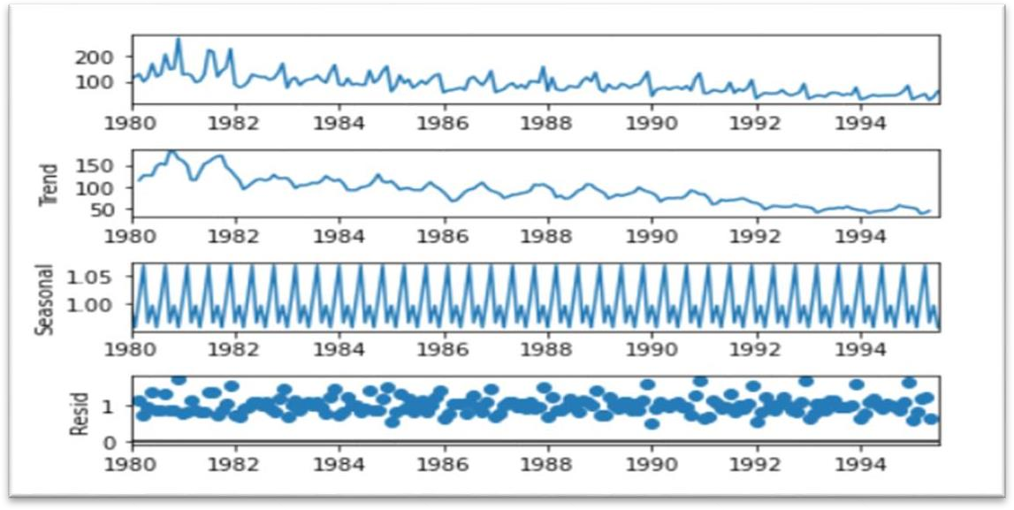

**(Multiplicative for Rose)**

* The residuals show a pattern of high variability across the period of time-series, which is more or less consistent are in both additive and multiplicative decompositions.
* The variance in residuals shows higher variance in the early period of the series, which explains the higher variance in observed plot at same time period.
* The additive model shows a mean variance around 0 and the multiplicative model shows a variance around 15%.
* Rose datasets show a clear decreasing trend as well as seasonality, multiplicative decomposition dictates the series the noise is reduced considerably in it also the seasonal patterns increase.

# Q3) Split the data into training and test. The test data should start in 1991.

* The train and test datasets are created with year 1991 as starting year for test data, using index. Year property of time series index.

**The plots of Sparkling as train and test are given here**

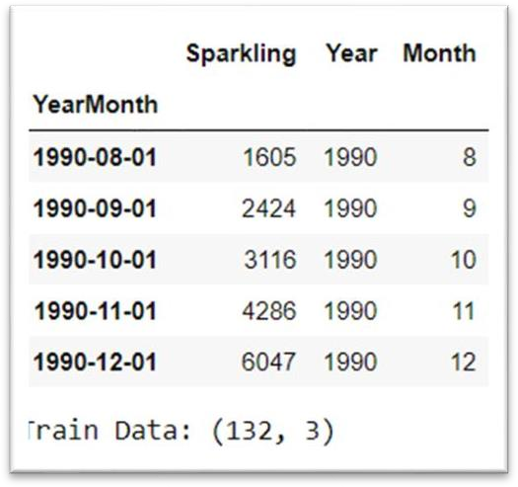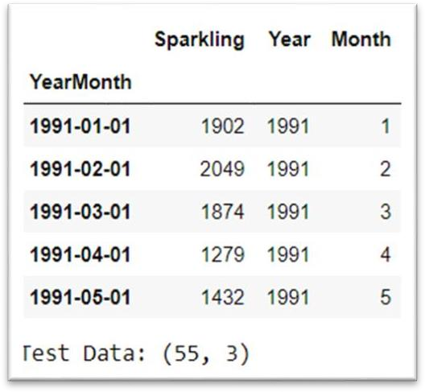

**(Sparkling Train Data) (Sparkling Test Data)**

**The plots Rose time-series as train and test are given here**

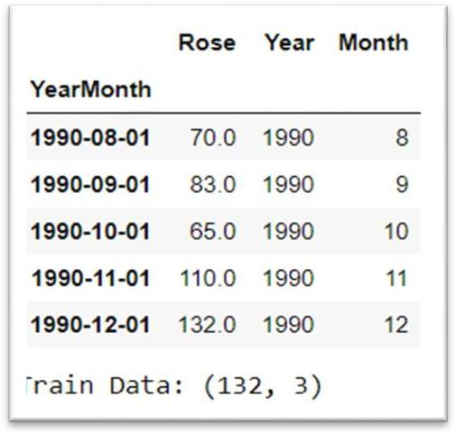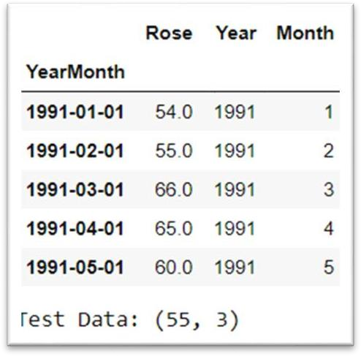

**(Rose Train Data) (Rose Test Data)**

# Q4) Build various exponential smoothing models on the training data and evaluate the model using RMSE on the test data.

#### Model 1- LINEAR REGRESSION

##### To regression the sale of Sparkling and Rose wines, numerical time instance order for both training and test set were generated and the values added to the respective datasets.

* 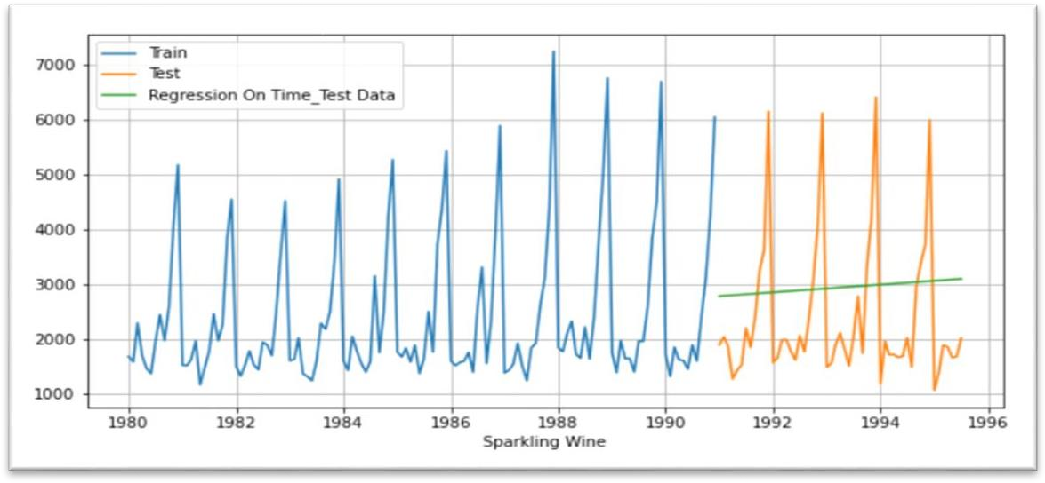The linear regression plots show a gradual upward trend in forecast of Sparkling wine, consistent with the observed trend which was not visually apparent.

**(Linear Regression for Sparkling)**

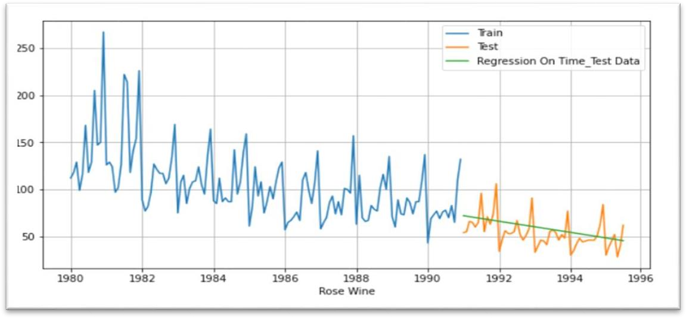

**(Linear Regression for Rose)**

##### The RMSE values for Test data sets are different.

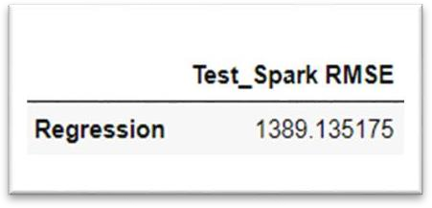 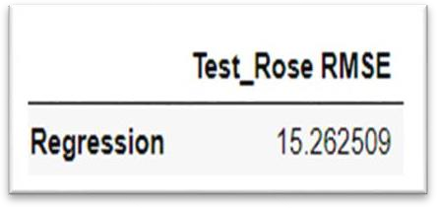

**(Regression for Sparkling & Rose)**

* The linear regression on the Rose dataset shows an apparent downward trend as consistent with the observed time-series.
* The model has successfully captured the trend of both the series but does not reflect any seasonality.

#### Model 2- NAÏVE FORECASTING

* In the Simple Average model, the forecast is done using the mean of the time-series Rose variable from the training set.
* The model is not capable of either forecasting nor able to capture the trend and seasonality present in the dataset.

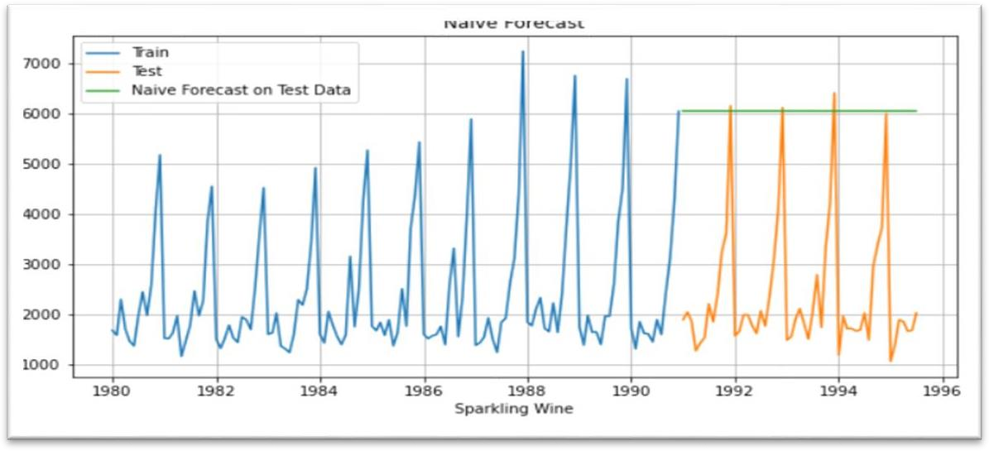

**(Naïve Forecasting for Sparkling)**

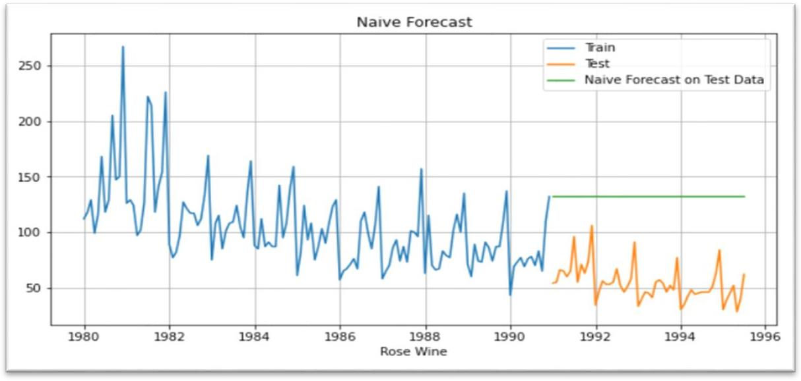

**(Naïve Forecasting for Rose)**

* For Sparkling the RMSE is consistent in both test and train datasets.

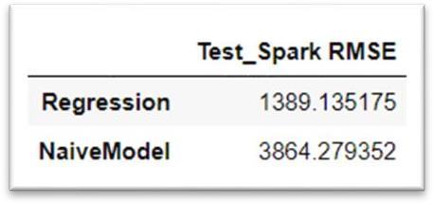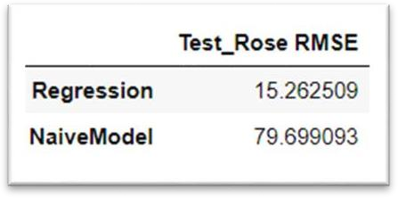

**(Naïve test for Sparkling & Rose)**

* The model is not capable of either forecasting nor able to capture the trend and seasonality present in the dataset.
* For rose the RMSE is consistent in both test and train datasets.

#### Model 3- SIMPLE AVERAGE FORECASTING

* For this simple average method, we will forecast by using the average of the training values.
* The model is not capable of either forecasting nor able to capture the trend and seasonality present in the dataset.

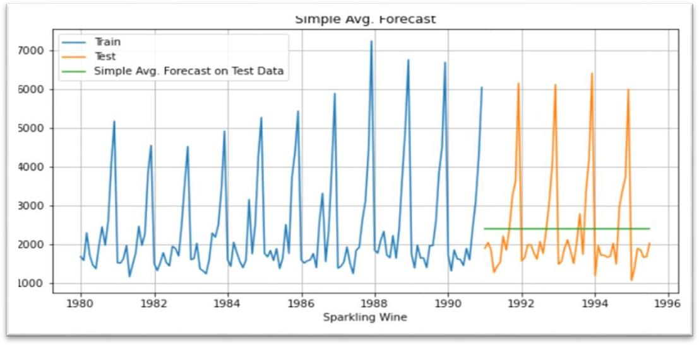

**(Simple Average Forecasting for Sparkling)**

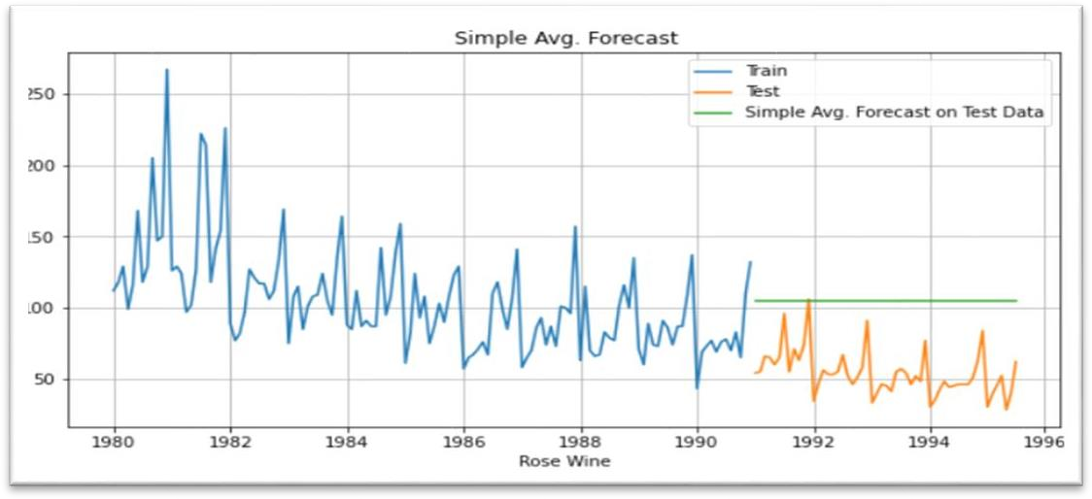

**(Simple Average Forecasting for Rose)**

* For Rose dataset, the model forecast is almost 100% error in test data and 25% in train.

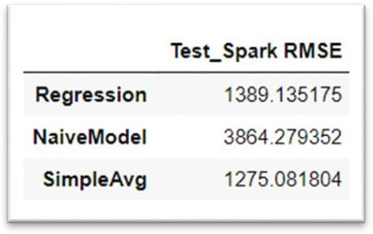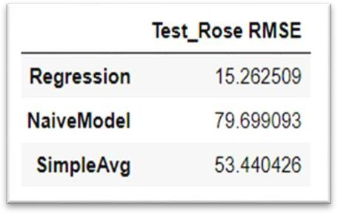

**(Simple Avg for Sparkling & Rose)**

* Due to the downward trend the performance in train data set is better than the test dataset.

#### Model 4- MOVING AVERAGE (MA)

* For the moving average model, we will calculate rolling means (or trailing moving averages) for different intervals. The best interval can be determined by the maximum accuracy (or the minimum error).
* The moving average models are built for trailing 2 points, 4 points, 6 points and 9 points.
* For Sparkling dataset, the accuracy is found to be higher with the lower rolling point averages.
* In moving average forecasts, the values can be fitted with a delay of n number of points.
* The best interval of moving average from the model is 2 point MA.
* For the moving average model, we are going to calculate rolling means (or moving averages) for different intervals. The best interval can be determined by the minimum error. The below plot shows the forecast for different rolling means:

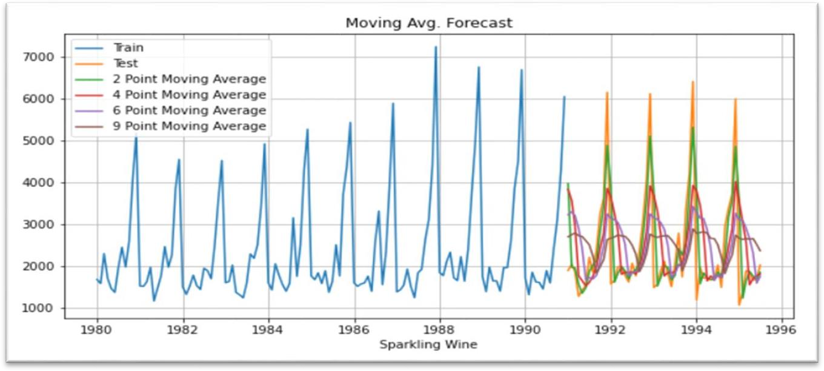

**(Moving Average Forecasting for Sparkling)**

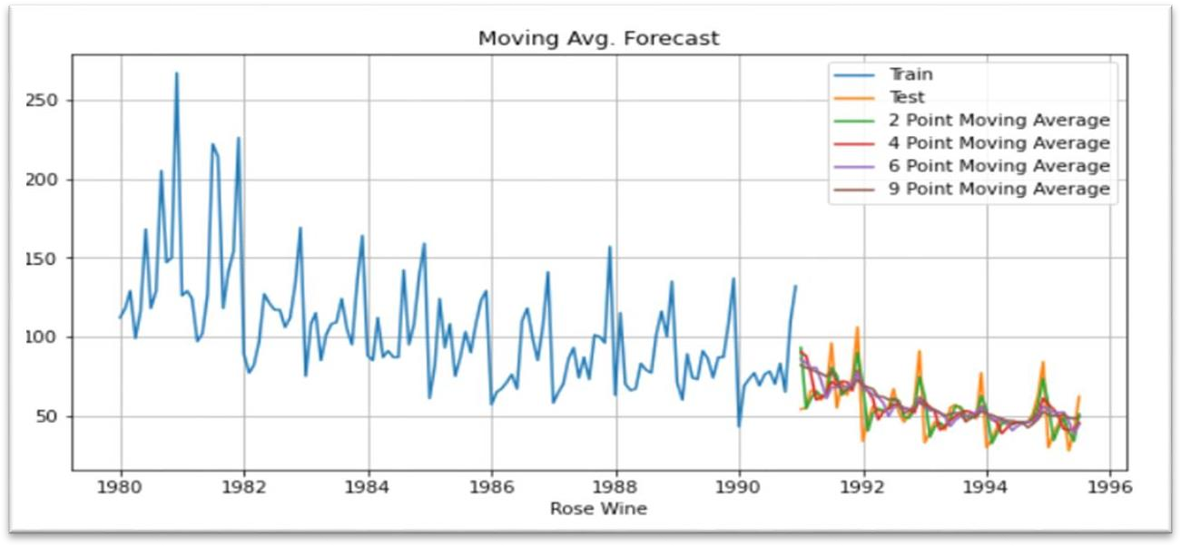

**(Moving Average Forecasting for Rose)**

* For Rose dataset the accuracy is found to be higher with the lower rolling point averages.
* 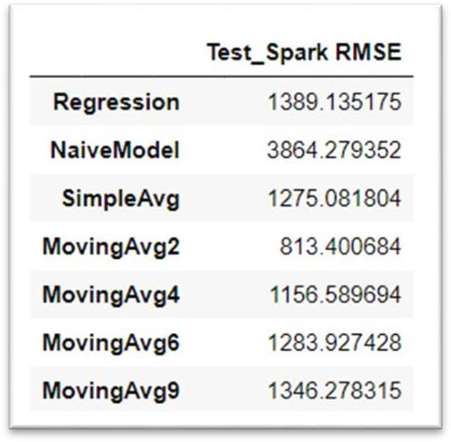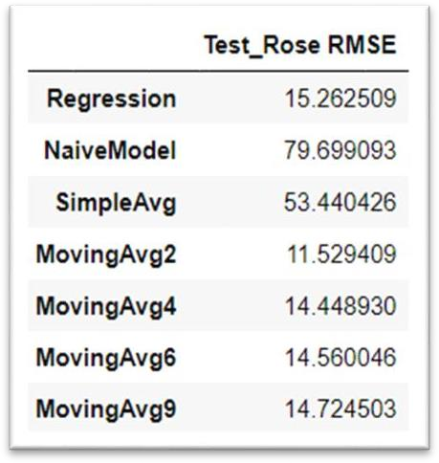The best interval of moving average from the model is 2 point MA.

**(Moving Average for Sparkling & Rose)**

#### Model 4- EXPONENTIAL SMOOTHING (Simple, Double & Triple)

* Exponential smoothing methods consist of flattening time series data.
* Exponential smoothing averages or exponentially weighted moving averages consist of forecast based on previous period’s data with exponentially declining influence on the older observations.
* Simple Exponential Smoothing (SES): The simplest of the exponentially smoothing methods is naturally called simple exponential smoothing (SES).
* This method is suitable for forecasting data with no clear trend or seasonal pattern.
* Since the model uses only one smoothing constant, it is called Single Exponential Smoothing.
* Sparkling data doesn't show visible trend however it shows seasonality.
* Rose data on the other hand shows both trend and seasonality, and all the Exponential models will still be built on both the datasets.
* Double Exponential Smoothing (DES): One of the drawbacks of the simple exponential smoothing is that the model does not do well in the presence of the trend.
* Applicable when data has Trend but no seasonality.

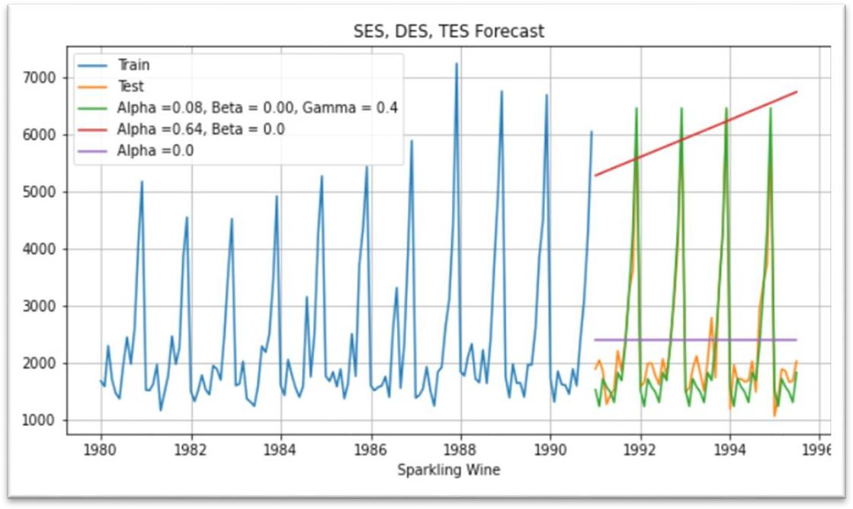

**(Exponential Smoothing for Sparkling)**

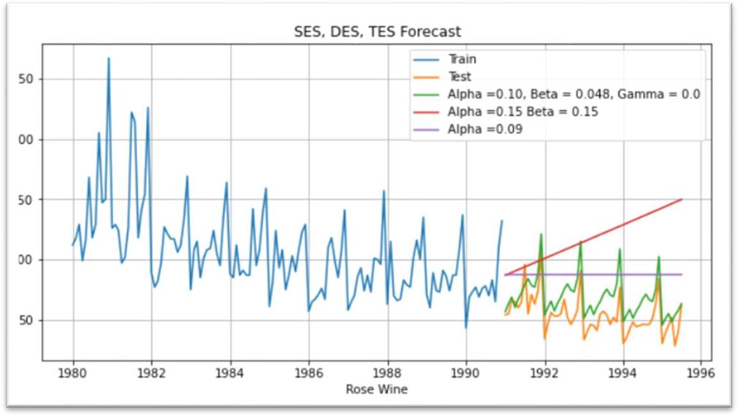

**(Exponential Smoothing for Rose)**

* Though our Sparkling data doesn't seem to have a visible trend we are still going to build this model for the project.

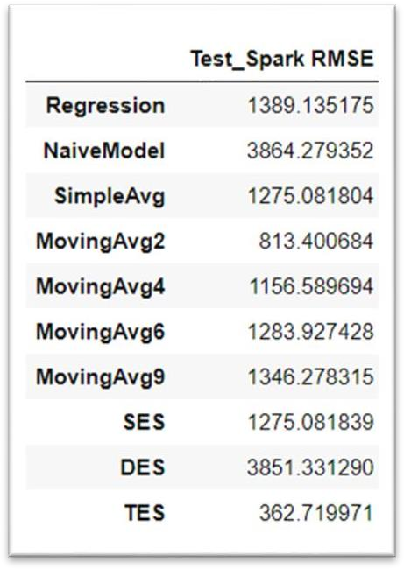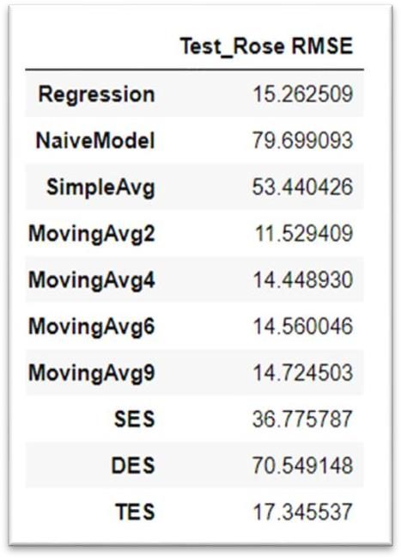

**(Exponential Smoothing for Sparkling & Rose)**

* Rose data has a clear trend from the plot above.
* we see that the Double Exponential Smoothing model has picked up the trend component as well.
* Our data has seasonality too so we will include one more smoothing parameter for seasonality which is gamma.
* We will use ETS (A, A, A) Holt Winter's linear method with additive trend and seasonality for Sparkling data and ETS (A, A, M) Holt Winter's linear method with additive trend and multiplicative seasonality for Rose wine data.
* And Hence This will called as Triple Exponential Smoothing (TES).

# Q5) Check for the stationary of the data on which the model is being built on using appropriate statistical tests and also mention the hypothesis for the statistical test. If the data is found to be non-stationary, take appropriate steps to make it stationary. Check the new data for stationary and comment. Note: Stationary should be checked at alpha = 0.05.

**Sparkling Train and Test set-**

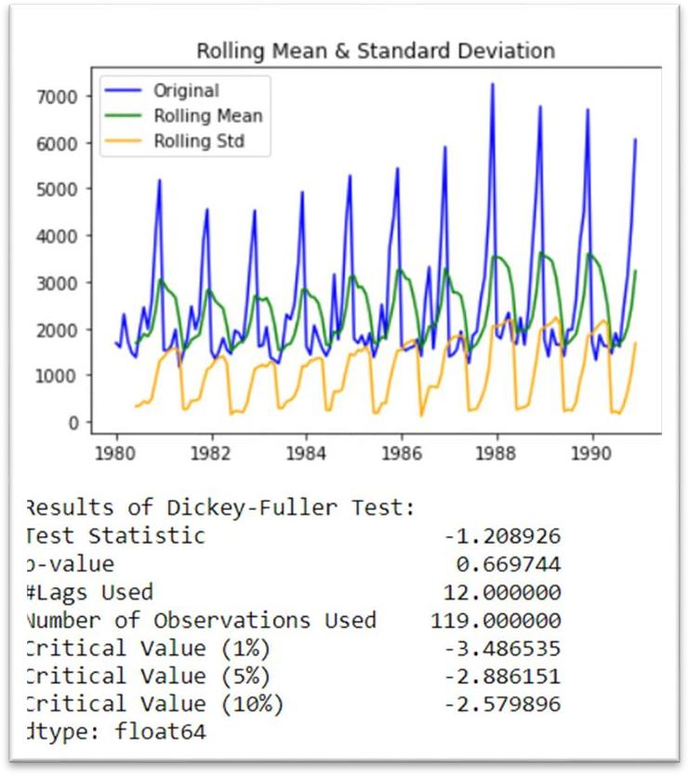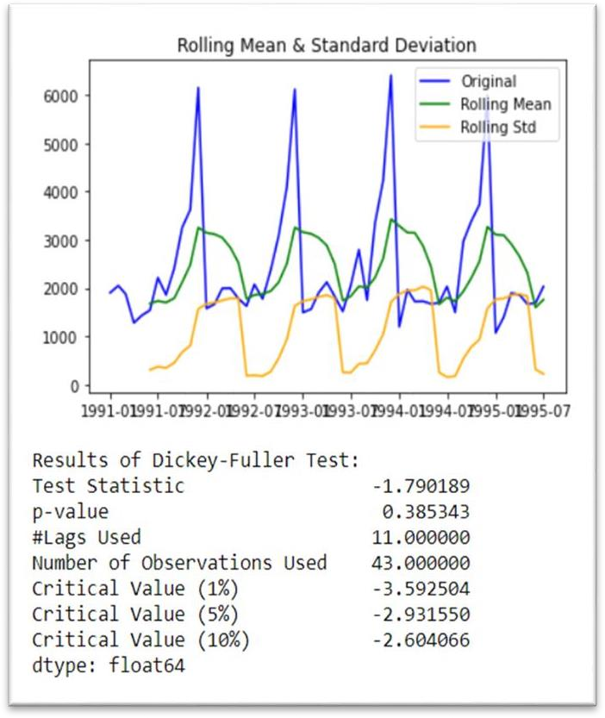

**(Sparkling Train and Test Set)**

* Null Hypothesis H0: The series is non-stationary
* Alternate Hypothesis H1: The series is stationary
* We cannot reject the null as the p values is greater than 0.05 (significance level) from the Augmented Dickey Fuller test above for Train of Sparkling Wine dataset.
* We can correct the non-stationary by using multiple methods like taking differences at various levels, using logged transformed series etc.
* Here we will take difference of level 1 of the original series.

#### Differentiated Sparkling Train and Test set-

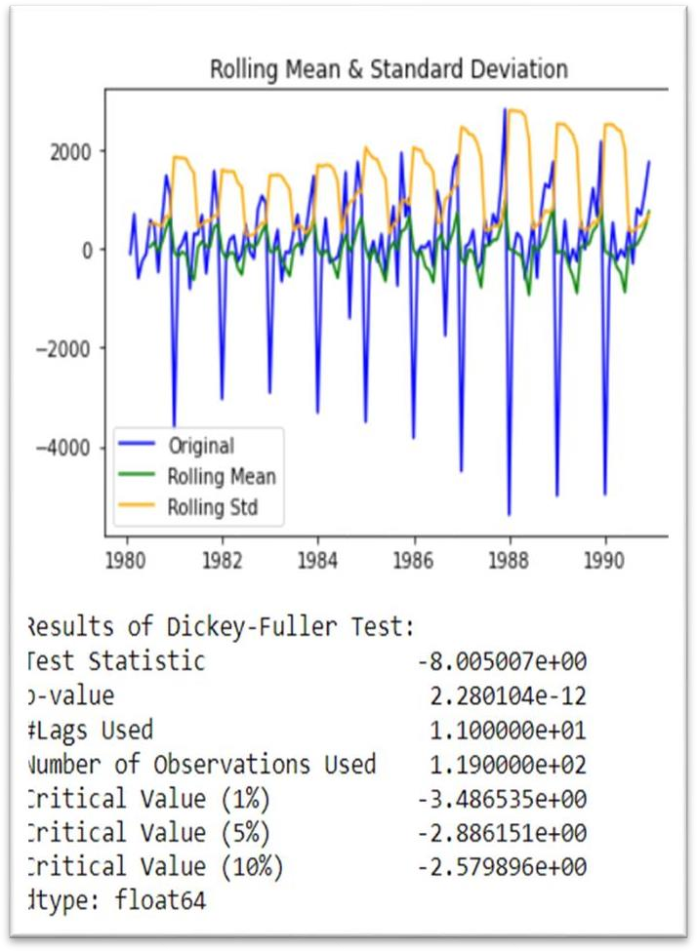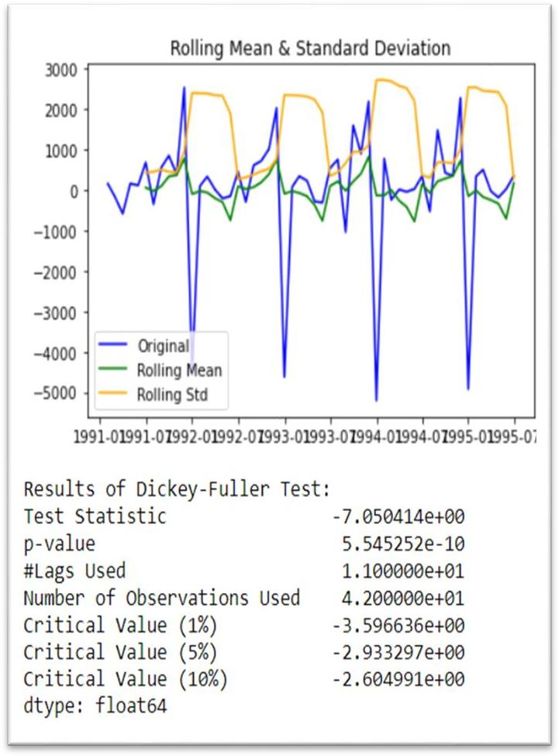

**(Differentiated Sparkling Train and Test Set)**

* We can now see that the p –value < than 0.05 so we can reject the null-hypothesis and accept the alternate. So, we say the series is stationary.

#### Rose Train and Test set-

* Null Hypothesis H0: The series is non-stationary
* Alternate Hypothesis H1: The series is stationary
* we cannot reject the null as the p values is greater than 0.05 (significance level) from the Augmented Dickey Fuller test above Train set of Rose Wine dataset.
* On the other hand we can reject the null as the p values is less than 0.05 (significance level) from the Augmented Dickey Fuller test above Test set of Rose Wine dataset.
* We can correct the non-stationary by using multiple methods like taking differences at various level, using logged transformed series etc.
* Here we will take difference of level 1 of the original train series and we will use the train dataset

##### as is.

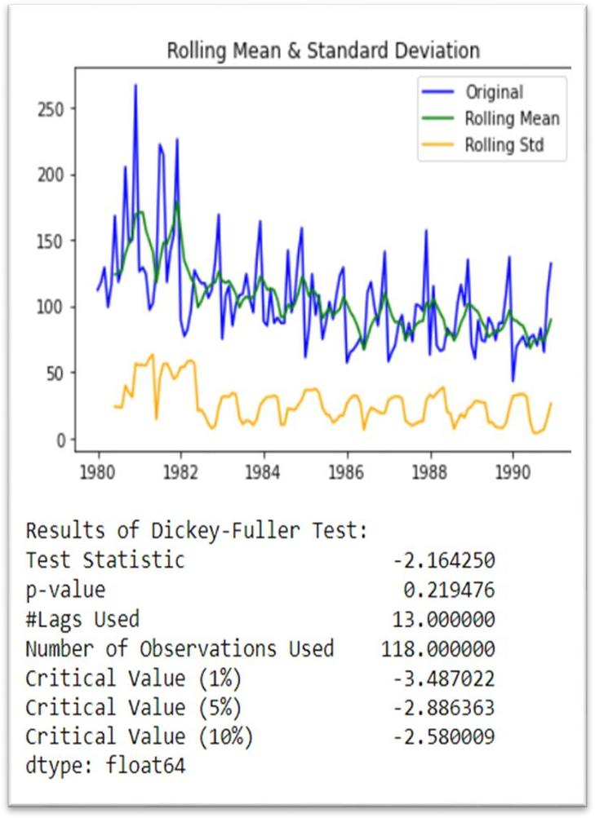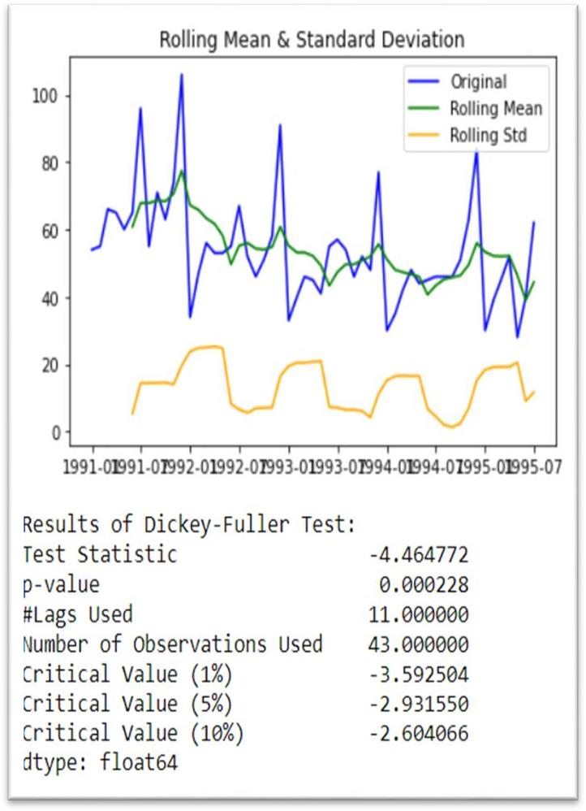

**(Rose Train and Test Set)**

#### Differentiated Rose Train and Test set-

* Null Hypothesis: The series has a unit root that is series is non-stationary.
* Alternate Hypothesis: The series has no unit root that is series is stationary.
* If we fail to reject the null hypothesis, it can say that the series is non-stationary and if we accept the null hypothesis, it can say that the series is stationary.
* The ADF test on the original Rose series retuned the below values, where p-value is greater than alpha .05 so we fail to reject the null hypothesis.

#### Train set-

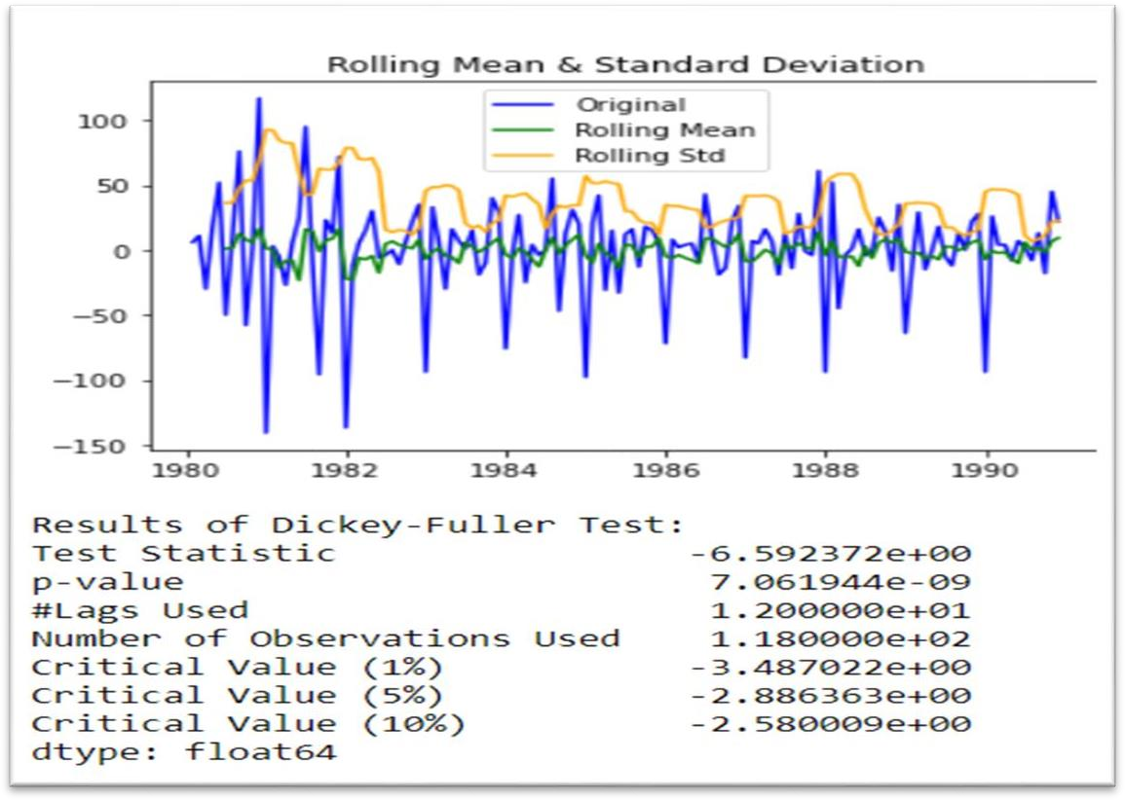

**(Rose Train Set)**

#### Test set-

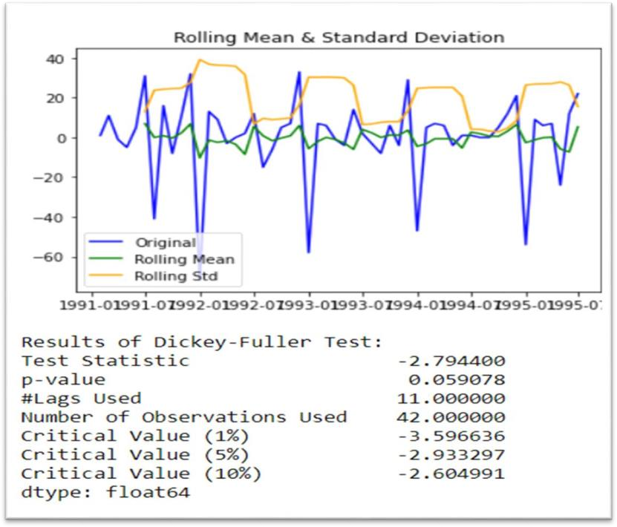

**(Rose Test Set)**

# Q6) Build an automated version of the ARIMA/SARIMA model in which the parameters are selected using the lowest Akaike Information Criteria (AIC) on the training data and evaluate this model on the test data using RMSE.

* As the Sparkling series of data contain seasonality component, we will be building SARIMA model, rather than ARIMA.
* Two iterations of automated SARIMA models were attempted in this exercise, one with original data and another with log transformation of the data, as an element of multiplicity in seasonality is suspected.
* The model built with original data is found to be higher in accuracy scores of RMSE, which is selected as the final model.
* The optimal parameters for (p, d, q) x (P, D, Q) were selected in accordance with the lowest Akaike Information Criteria (AIC) values.

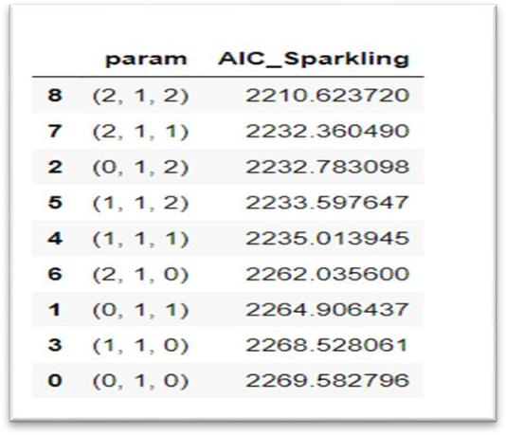

**(AIC Sparkling)**

* The top three models with lowest AIC values are as given. As per the AIC criteria, the optimum values for final SARIMA model selected are (3, 1, 3) x (3, 1, 0, 12).

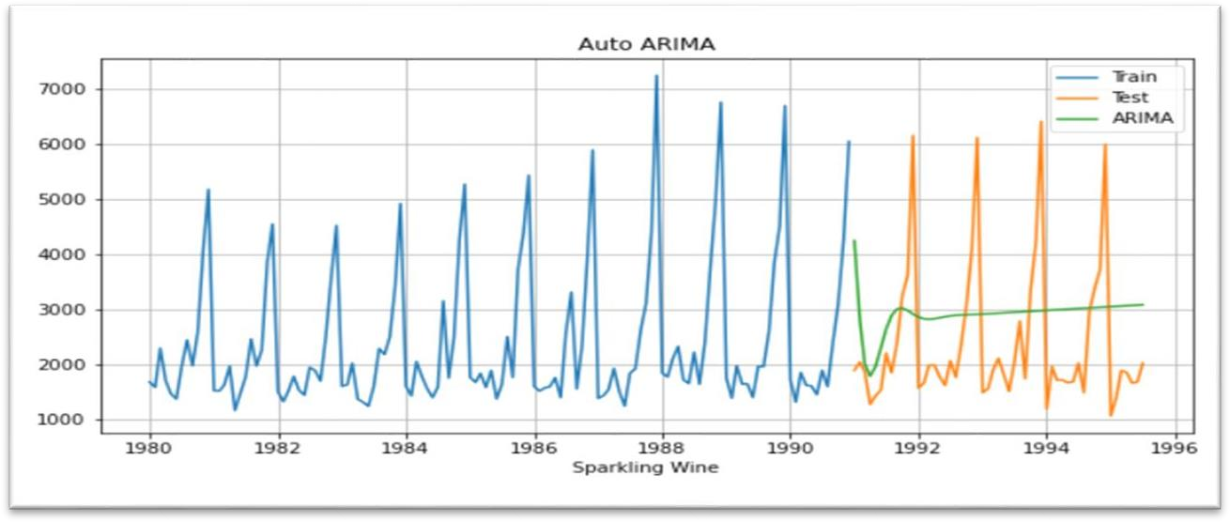

**(AIC for Sparkling)**

* The diagnostics plot of the model was derived and the standardized residuals are found to follow a mean of zero, and the histogram shows the residuals follow a normal distribution.
* The Normal Q -Q plot also shows that the quintiles come from a normal distribution as the point’s forms roughly a straight line.
* The RMSE values of the automated SARIMA models built are given here.
* From the below model summary, it can be inferred that AR (1), MA (1), MA (3), MA (2) terms has the highest absolute weightage.
* From the p-values it can be inferred that terms AR (1), AR (2), MA (1), MA (2), MA (3) and seasonal AR (1) are significant terms, as their values are below 0.05

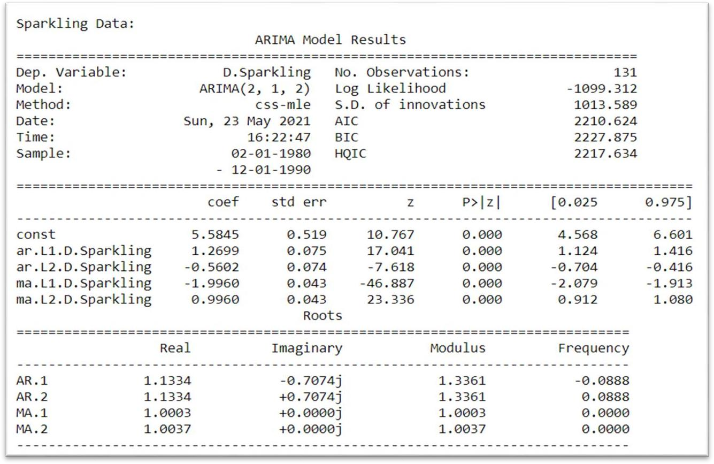

**(ARIMA Model Results for Sparkling)**

* As the Rose series of data contain seasonality component, we will be building SARIMA model, rather than ARIMA.
* Two iterations of automated SARIMA models were attempted in this exercise, one with original data and another with log transformation of the data, as the seasonality got apparent multiplicity.
* The model built with log transformed data is found to be higher in accuracy scores of RMSE which is selected as the final model.

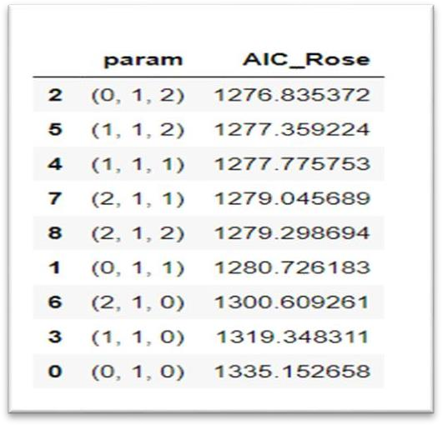

**(AIC for Rose)**

* To handle multiplicity of seasonality, the data was log transformed to make it additive.
* The optimal parameters for (p, d, and q) x (P, D, Q) was selected in accordance with the lowest A kaki Information Criteria (AIC) values.
* The top three models with lowest AIC values are as given here and the final selected one is (1, 0, 0) x (1, 0, 1, 12).

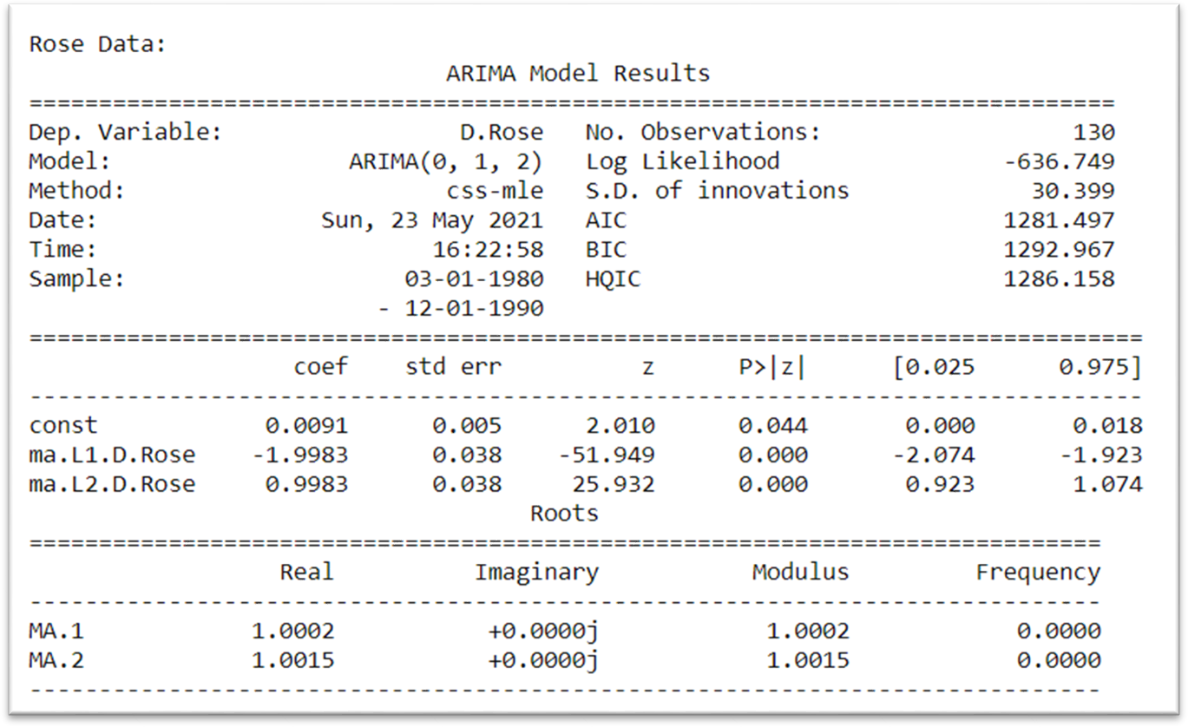

**(ARIMA Model Results for Rose)**

* The diagnostics plot of the model was derived, and the standardized residuals are found to follow a mean of zero, and the histogram shows the residuals follow a normal distribution.
* The Normal Q -Q plot also shows that the quintiles come from a normal distribution as the point’s forms roughly a straight line.
* The correlogram shows the autocorrelation of the residuals and there are no points significant above the confidence index.
* The RMSE values of the automated SARIMA models built are given here.

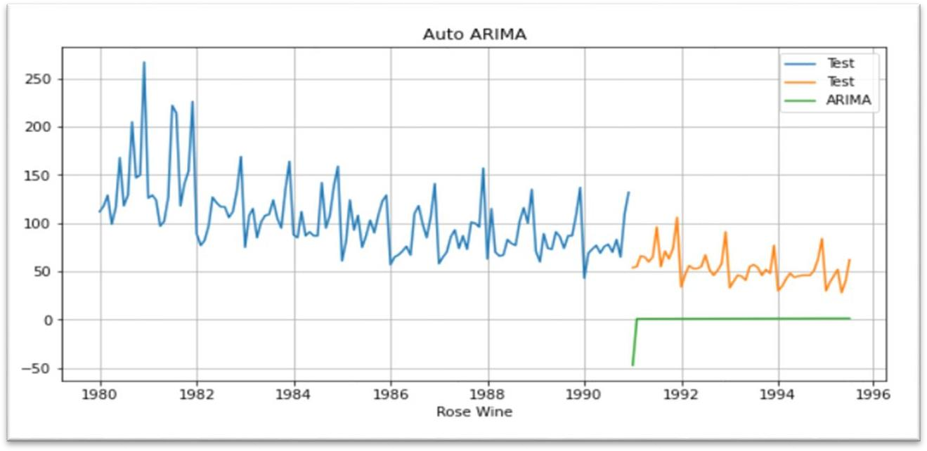

**(ARIMA for Rose)**

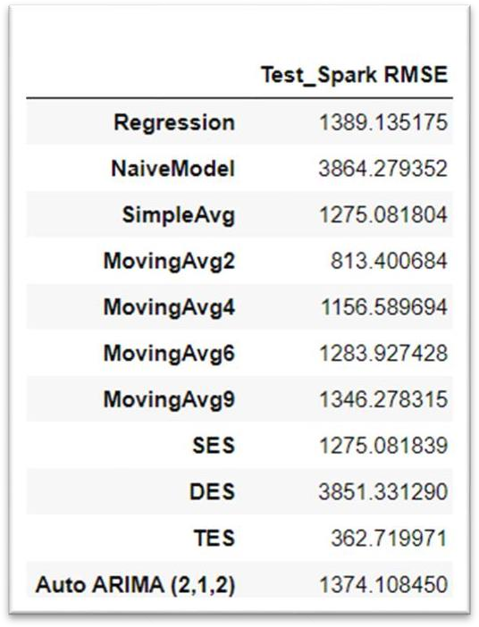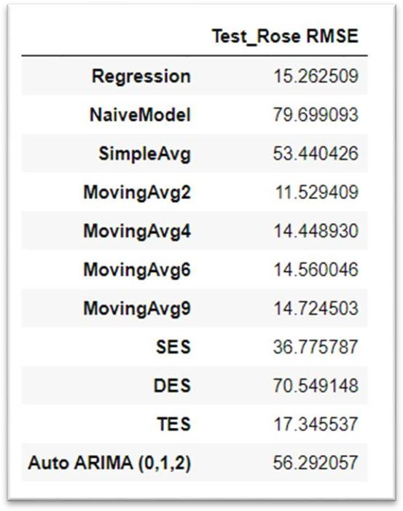

**(RMSE for Sparkling & Rose)**

# Q7) Build a table with all the models built along with their corresponding parameters and the respective RMSE values on the test data.

* The overall comparison of all the time-series forecast models are listed below in accordance with increasing RMSE against test data or in the order of decreasing accuracy.
* Triple Exponential Smoothing is found to be the best model for sparkling Wine and Rose Wine followed by which Rose wine tends to have 2 point Moving Average (MA) as best Model.

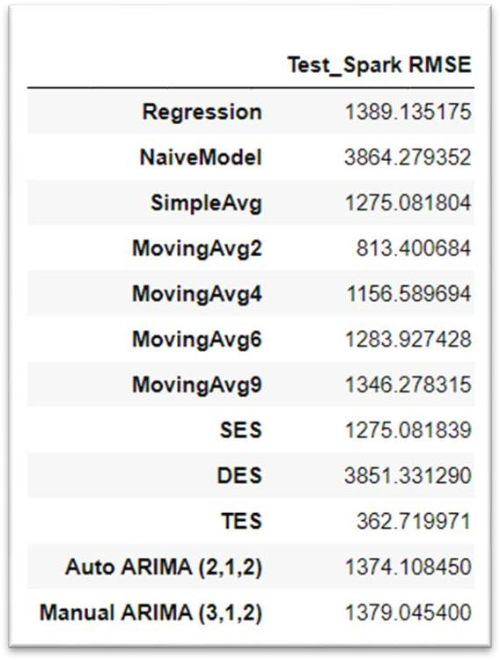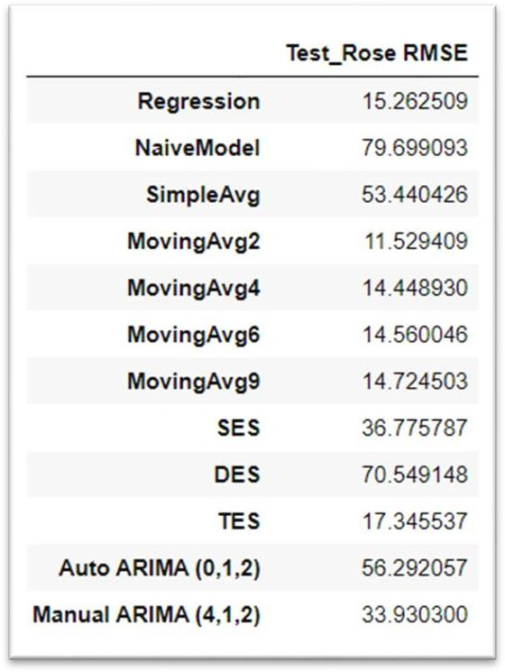

**(RMSE for Sparkling & Rose)**

# Q8) Based on the model-building exercise, build the most optimum model(s) on the complete data and predict 12 months into the future with appropriate confidence intervals/bands.

* For Sparkling dataset, we see that Triple Exponential smoothing gives the best forecast, so we will move forward with that for forecasting.

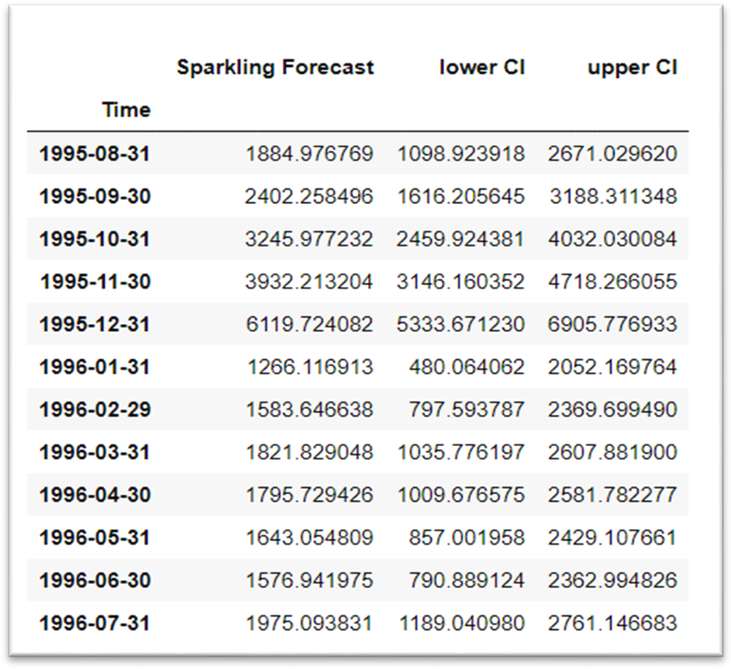

**(Sparkling Data Set)**

#### SPARKLING Forecast Triple Exponential Smoothing (TES) on train and test dataset

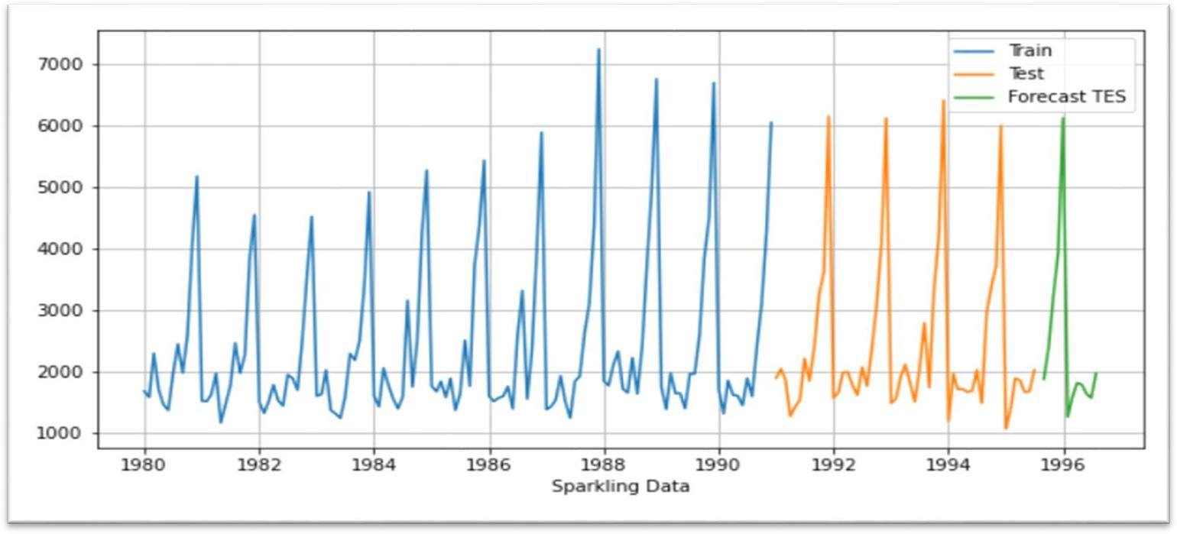

**(Sparkling Forecast Train & Test Date Set)**

#### SPARKLING WINE FORECAST-

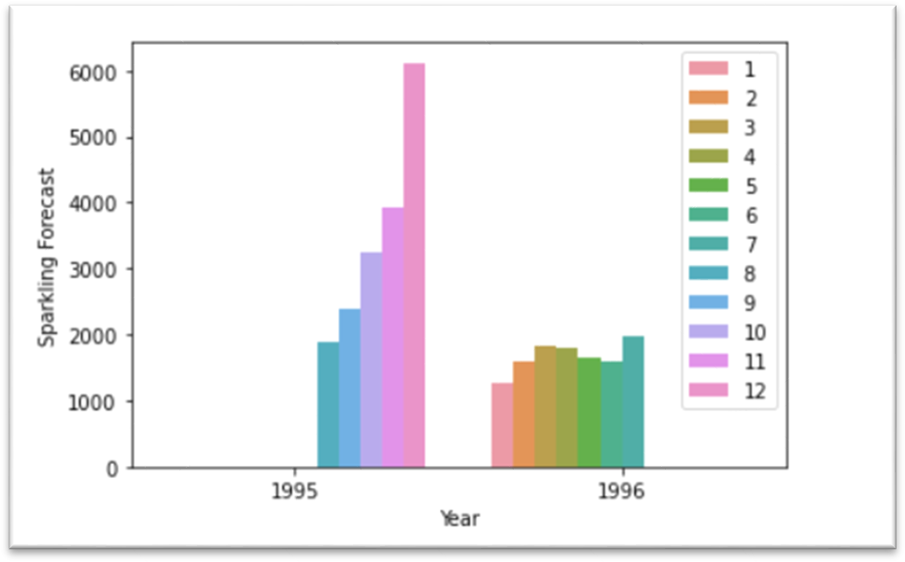

**(Sparkling Wine Forecasting)**

* For Rose dataset moving avg. shows the best RMSE, however since the window chosen was very small (2, 4, 6, 9) it was natural it was going to work well on Test set.
* The other model which gave the best RMSE was TES and Manual SARIMAX (4, 1, 2) (3, 0, 2, 12). We will build a final model on the entire Rose dataset using SARIMAX

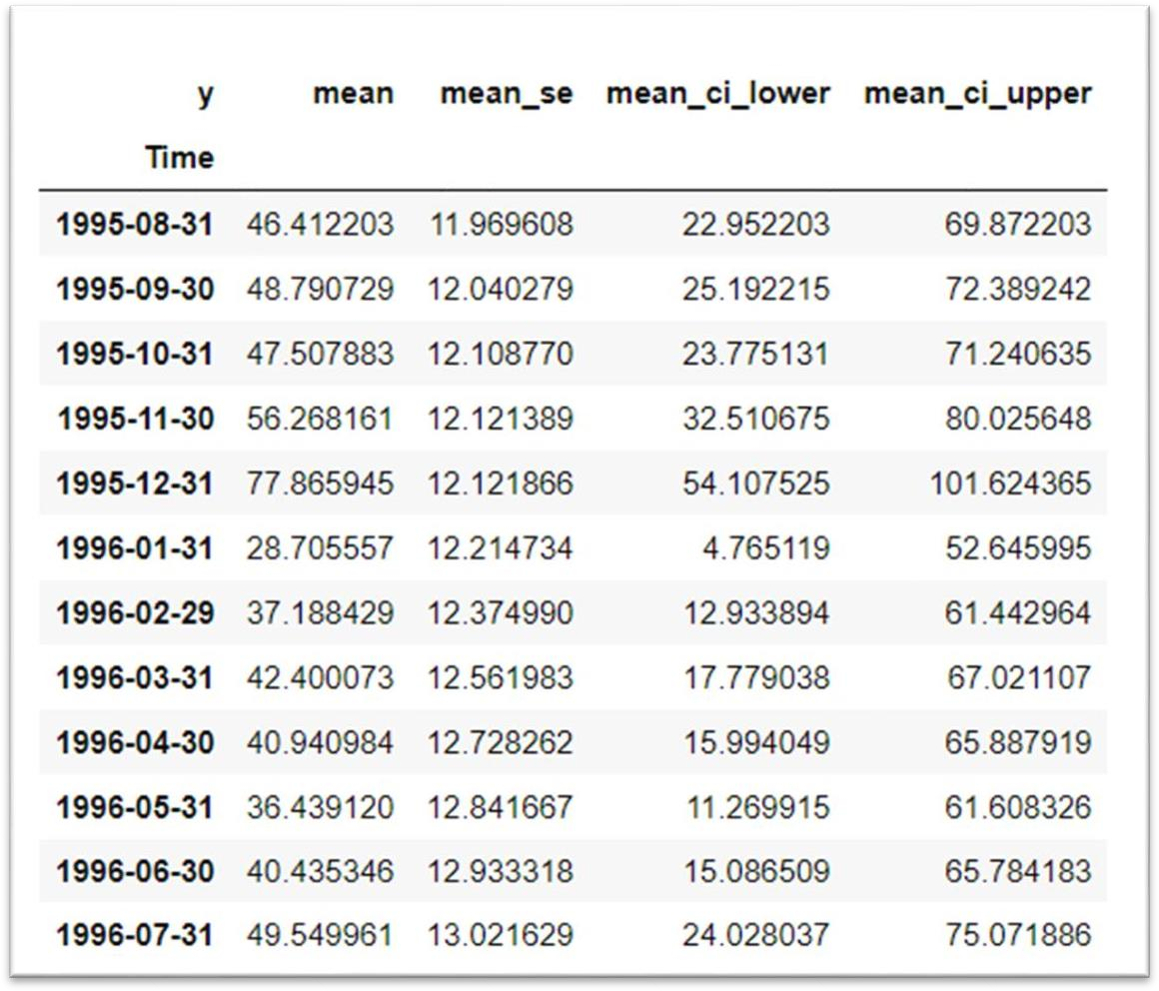

**(Manual SARIMAX for Rose)**

#### ROSE Forecast SARIMA on train and test dataset-

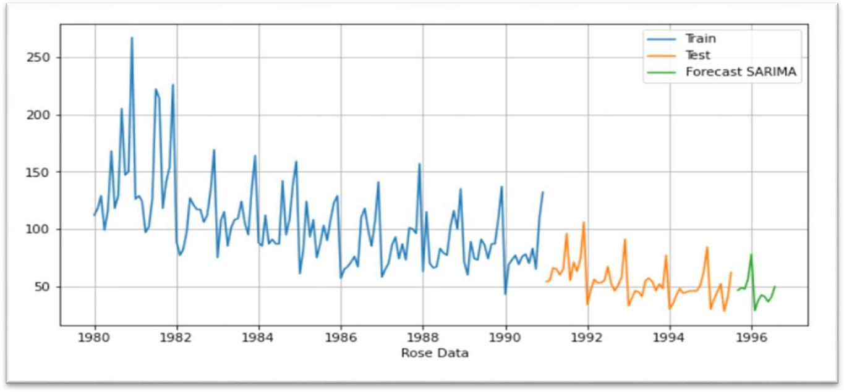

**(Rose SARIMA Train & Test Data Set)**

#### ROSE WINE FORECAST-

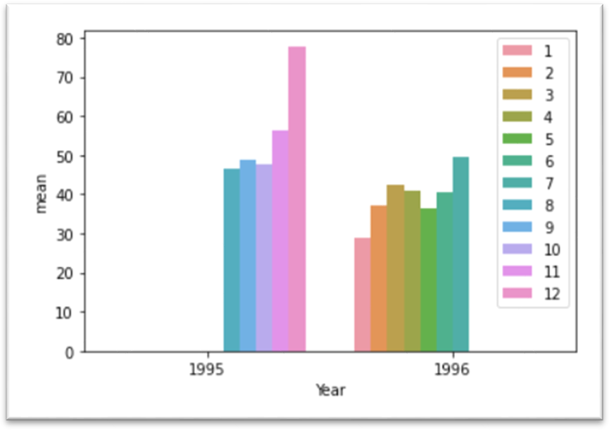

**(Rose Wine Forecasting)**

# Q9) Comment on the model thus built and report your findings and suggest the measures that the company should be taking for future sales.

#### SPARKLING-

**Findings:**

* Based on the overall model evaluation and comparison, Triple Exponential Smoothing (Holt Winter’s) and SARIMA are selected for final prediction into 12 months in future.
* TES model alpha: 0.1, beta: 0.2 and gamma: 0.2 & trend: ‘additive’, seasonal:

‘Multiplicative’ is found to be the best model in terms of accuracy scored against the full data.

* The model predicts continuation of the trend in sales and seasonality in yearend sales. The prediction shows a stabilization of downward trend, as the sales will be almost same as previous observed year.
* The 12-month prediction of the TES model is as below.

#### Suggestion:

* TES (Triple Exponential Smoothing) has worked the best for the forecast with lowest RMSE on test data 30
* The Forecast for the Next 12 Months is slightly over the sales of the previous 12 months.
* The Sparkling Wine trend tend to go up in last two months probably because of Halloween and Christmas Months (Holiday season)
* The ABC Wines can market to increase the sales towards the beginning and mid of the year, it can introduce discounts during the low sales.
* The ABC Wines can tie up with Wine Reviewers and Bloggers to increase the traffic towards the ABC Wine Brand.
* The ABC Wines Can also improve their marketing skills to improve the sales compared to previous years.

ROSE-

#### Findings:

* The SARIMA model is chosen as the final model for prediction on Rose dataset, as it provides confidence interval and better explain ability of the model.
* The diagnostics plot of the model shows that the residuals follow a normal distribution with most values around mean zero. The residuals also follow a straight line in normal QQ plot.
* The model summary also provides valuable insights in the model. It can be understood that MA (1) and seasonal MA (1) term has the highest weightage. The p-values indicate that the terms MA (1) and Seasonal MA (1) are the most significant terms.
* The rest of the p-values got values higher than alpha 0.05, which fails to reject the hull hypothesis that these terms are not significant.

#### Suggestion:

* From the August to December month shows the increasing trend
* The trend tends to decrease or decay towards the beginning of the month
* The ABC Wines can do some promotional activities and implement some discounts for the spring season.
* Unlike Sparkling wine, Rose wine sells very low number of units
* Apart from higher sale in November and December months, Rose sales will be above average in the summer months of July and August.
* The winery should research on the low demand for Rose wine in market and make corrective actions in either recipe or marketing segment of the Wine sales.